

ST6012CEM User Experience Design

Report on

Fit-Start Application

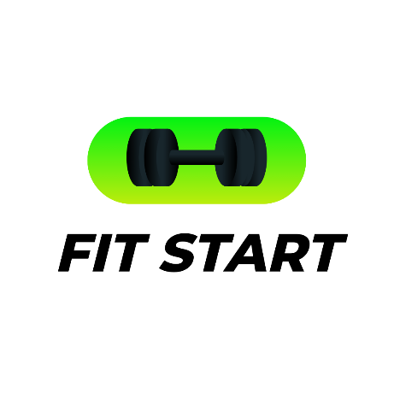

Submitted by: Rajil Shrestha

Coventry ID: 220020

Batch: 32 ‘A’

Module Leader: Pratik Bhusal

Contents

Introduction 5

Literature Review 5

Nike Training Club 5

Strava 6

Inspiration for the App 7

PACT Analysis 8

People 8

Activities 8

Contexts 8

Technologies 9

Requirement Analysis 9

Functional Requirements 9

Non-Functional Requirements 9

BPI Integration 10

UI Diagram 11

Low-Fidelity Prototype 12

How Wizard of Oz Testing Was Conducted 12

User Identification 12

Insights and Adjustments 12

Future Improvements 13

High-Fidelity Prototype 15

1. Visibility of System Status 15

2. Match Between System and the Real World 16

3. User Control and Freedom 16

4. Consistency and Standards 17

5. Error Prevention 18

6. Recognition Rather Than Recall 19

7. Flexibility and Efficiency of Use 21

8. Aesthetic and Minimalist Design 22

9. Help Users Recognize, Diagnose, and Recover from Errors 23

10. Help and Documentation 24

Improvements 25

Final Product 25

Flat Design 26

Golden Path 26

Shortest Path 27

3-Tap Concept 27

Crow’s Foot Notation 28

Hex Principle 28

Metaphor 28

6:3:1 Design Rule 29

Emotional Design Model 30

Conclusion 30

References 31

Appendix 32

Links 32

Persona 33

Consent Form 37

Low Fidelity Prototype Pictures 44

# Table of figures

Figure 1 Nike training club ui 6

Figure 2 strava ui 7

Figure 3: UI diagram 11

Figure 4 exercise popup 15

Figure 5 success pop up 16

Figure 6 icons 16

Figure 7 easy termination 17

Figure 8 easy cancellation of profile edit 17

Figure 9 consistent design 18

Figure 10 uniform appearance of pop-ups 18

Figure 11 update confirmation 19

Figure 12 homepage 20

Figure 13 Leaderboards 20

Figure 14 different steps of password recovery 21

Figure 15 navigation bar and its shotcuts 21

Figure 16 editable popup 22

Figure 17 sleek homepage design 22

Figure 18 account delete confirmation 23

Figure 19 Contact us page 24

Figure 20 about us page 24

Figure 21 flat design 26

Figure 22 Different sections on home page 27

Figure 23 crows foot o nav bar 28

Figure 24 Leaderboards 29

Figure 24 Leaderboards 29

Figure 25 6:3:1 rule implemented on colors 29

Figure 25 6:3:1 rule implemented on colors 29

# Introduction

The industry of exercising has witnessed a large move to digital devices for the aim of accomplishing those things which stimulate good health, monitor progress, and community interaction (World Health Organization, 2020). In order to cater to the ever-increasing need for these platforms, Fit Start was designed to function as an all-elegant fitness software that delivers health and fitness tracking in a holistic fashion (Smith, 2022). The software combines such elements as workout planning, now or later, fitness metrics, leaderboards for gamification, and a user-friendly interface to the users who would like to attain their fitness targets (Norman, 2013). The objective of Fit Start is built in the premise that the app should provide comfort of use and engagement and by so doing, bridge the gap between users of digital solutions and fitness lovers (Freedman, 2019).

However, a great many of contemporary fitness apps do not deal with the fundamental worries that users need answering (Cooper et al., 2007). These apps have such elements as unorganized navigation, irrelevant content, and insufficient feedback, which commonly contribute to a drop-in user activity. As a user, you will have challenges, whichever it may be, with navigating these apps, accessing the necessary features or obtaining clear feedback on your progress. The dullness of the practice of gamification is a main reason it is not an effective motivator. Fit Start was ideated as a solution to these challenges and it follows the concept of a tidy, easy to use, and gamified platform which is however versatile and adaptable. The software is designed to instill the sense of being more alive and self-empowered in users by making a trouble-free and deserved digital experience the uniting point.

# Literature Review

Fitness applications play a key role in fostering physical well-being by delivering tools for activity tracking, training assistance, and motivation (Kettunen, 2021). Among the most renowned platforms, Nike Training Club and Strava highlight the varied techniques employed to engage users. Their strengths and limits have guided the design and development of this fitness application.

## Nike Training Club

**Nike Training Club**

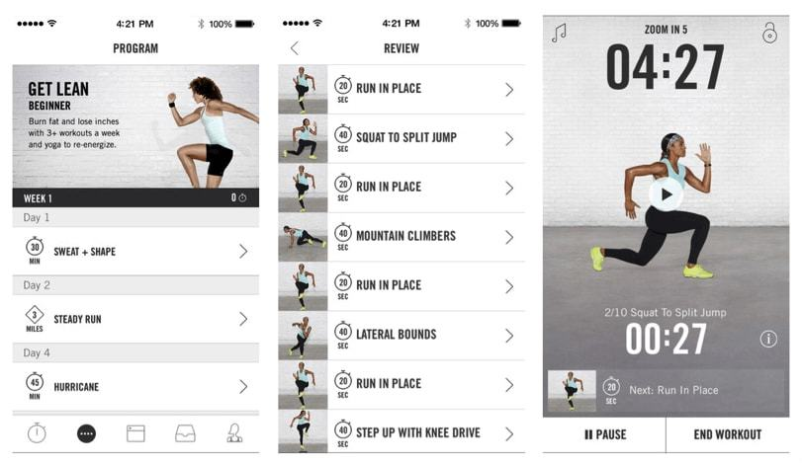Nike Training Club is known for its wide library of guided workouts and individualized training routines (Nike Inc., n.d.). The app’s layout is clean and user-friendly, allowing users to navigate effortlessly via video courses and workout routines tailored to their preferences. It stresses simplicity and education, delivering precise instructions that make workouts accessible to people of all fitness levels.

Figure 1 Nike training club ui

However, Nike Training Club lacks gamification components, such as leaderboards or challenges, which can promote user engagement by adding an aspect of competitiveness and community. While its concentration on individual progress is vital, the absence of social and competitive components restricts its ability to promote continuous motivation.

## Strava

Strava stands out for its ability to mix fitness tracking with social connection (Strava, n.d.). It is particularly popular among runners and bikers, giving features like leaderboards, achievements, and virtual badges. These gamification aspects have successfully motivated users to keep active, often competing with friends and peers on activity rankings.

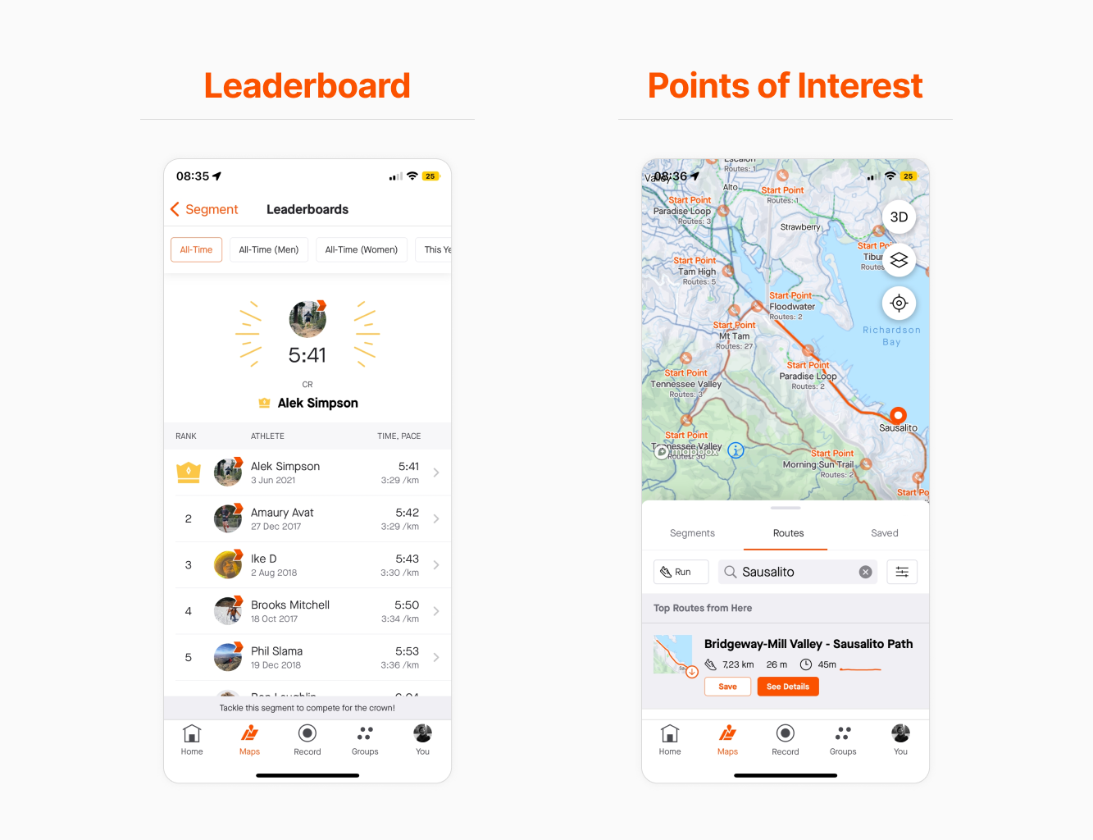

Figure 2 strava ui

Despite its unique features, Strava’s design might feel intimidating, especially for newcomers. The rich statistics and large range of capabilities, while valuable to advanced users, may alienate new users wanting a more straightforward experience.

# Inspiration for the App

By examining these platforms, crucial findings have been included into the design of this fitness application (Brown, 2009). Inspired by Nike Training Club’s focus on simplicity, the app features an easy layout that ensures accessibility for users of all ability levels. From Strava, the app uses a leaderboard system, bringing a gamification element that pushes users through healthy competition.

This balanced approach bridges the gap between individual fitness tracking and community participation, addressing the drawbacks of existing apps while harnessing their strengths (Fogg, 2009).

# PACT Analysis

## People

The audience for the Fit Start app generally consists of people who are either amateurs or professionals in the exercise sector (Harrington, 2011). As a remark, the starting users are expected to be supplied with the inspiration and encouragement they need to lead a fit lifestyle, while more experienced users will be motivated to compete with others on the leaderboard and therefore closely monitor their progress. The potential audience which specifically includes white-collar workers, college students, and fitness center attendees are of every variety. Consequently, the product ought to be developed in such a way that it is convenient for all users no matter how much computer experience they possess.

## Activities

The software stands out with some of the basic features: entering workouts, tracking progress, and battling for the highest position on the scoreboard (Deterding et al., 2011). Users can also keep a journal of the workouts, verify the summary of their progress, and be part of the many challenges of the gamified platform. By a single easy focused menu, time wastage is not predicted since users may check out their preferred functions, such as exercises, food monitoring, and performance rates, on time.

## Contexts

It is in the best interest of the app to be engaged in a never-ending sequence of such activities as in different events, for instance, doing exercises in health clubs, having a diet plan, or just simply surfing on the computer (Norman, 2004). For this reason, it can be easily accessed anywhere and anytime, using all the devices that have a web browser, such as smartphones, tablets, and computers. Both the responsiveness of the app and how easy it is to use it, are assets that make it possible for the user’s management of the most critical difficulties in record time, just like this is done also in the case of the live workout recording.

## Technologies

This particular application uses the newest and the greatest mobile-friendly technology that guarantees the best performance offered in end-to-end web development (Schwaber & Sutherland, 2020). The user interface was developed with Figma and comprises the design of a web page that features interactive elements and beautiful images. An crucial criteria that the app’s design had to achieve was scalability. This was owing to the teeny-tiny likelihood that in the future, there might be an upgrade in the device’s software.

## Requirement Analysis

Cospace established Fit Start app requirements through a system of Business Process Improvement (BPI) which gave the needed definition. The crew at BPI refined present methodologies for fitness tracking and incentive to create an effective user-centered solution using Business Process Improvement strategies (Cooper et al., 2007). The development process began by examining common fitness applications to generate optimization targets that resulted in an efficient intuitive solution.

## Functional Requirements

* **Workout Tracking**: Through the app platform users may track their workouts by displaying their workout duration alongside their burned calorie count and their growing progress outcomes.
* **Leaderboards**: The system incorporates gamification components which help users measure their performance against others as they work towards obtaining personal records.
* **User Profiles**: Users need to set up profiles by entering profile information which adapts according to their fitness ambitions and custom selections.
* **Feedback Mechanisms**: A system generates instant feedback for all completed procedures so users keep continually informed about their progress (Norman, 2013).

## Non-Functional Requirements

* **User-Friendly Navigation**: The program needs user-friendly navigation since users should easily operate all vital functions.
* **Visual Design**: The visual structure of a system involves both cleanliness and consistency and aesthetic design for better user engagement.
* **Performance**: Users need speedy replies from the app since higher speed leads to better user happiness.
* **Accessibility**: The system requires interface elements that facilitate beginner through experienced fitness enthusiast accessibility.

# BPI Integration

BPI processes received a full evaluation for deleting duplications along with enhancing user interface operation. The application now contains an easy-to-use graph that lets users log workouts coupled with leaderboards removal of superfluous procedures. Testing low-fidelity prototype versions offered input to streamline the application through eliminating extraneous elements such as the shop to restrict the system’s emphasis. The continual user-centered process of refinement led to needs that supported the development of an effective reliable and entertaining fitness platform.

**Link for detailed User Stories:**  
<https://docs.google.com/spreadsheets/d/14rrCvxF_MD6JsW80gRiQVvrzAqSOawMfgLcUFuNFRE4/edit?usp=sharing>

# UI Diagram

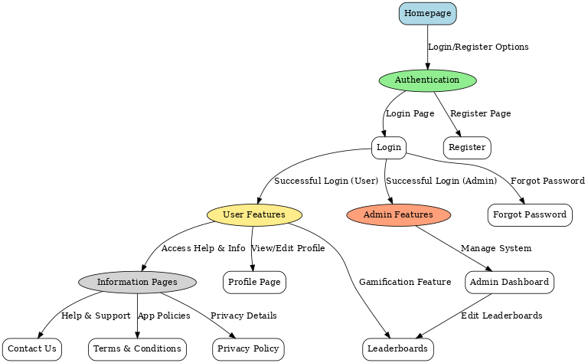

UI Diagram of FitStart Web App

Figure 3: UI diagram

# Low-Fidelity Prototype

A low fidelity prototype design for the Fit Start app employed paper sketches to create visual representations of app organization and navigation sequence (Nielsen, 1994). The prototype offered core components and interface paths to allow users an opportunity for early usability and design feedback before implementing interactive features. The paper prototype provides an easy approach to track early design issues that users can confront when utilizing the basic app structure.

## How Wizard of Oz Testing Was Conducted

The paper prototype consisted of principal screens including homepage login and profile and leaderboard but the shop element received feedback-driven elimination. Users performed tasks with established objectives throughout the testing phase including leaderboard navigation and workout logging. During testing sessions, the facilitator physically switched between paper screens while providing suitable visual responses. By providing the necessary relevant paper designs the designer emulated both workout selection along with leaderboard watching.

Everyone who utilized the system participated in an observational study that tracked users through each step and highlighted occasions when they were unclear about what to do next. The subject behavior study focuses on tracking their behaviors combined with accumulated verbal remarks and system problem points such as confused path design and absence feedback options.

## User Identification

User selection proceeded based on the personas from requirement analysis. Our personas featured three user types which included novices who lacked fitness app knowledge along with casual users who sought frequent fitness tracking and competitive users whom leaderboards stimulated. User recruitment centered on fitness communities with extra members from personal networks to achieve diverse participant feedback (Brown, 2009).

## Insights and Adjustments

User testing of our paper prototype gave feedback that revealed many portions needed extra development. Users struggled to navigate correctly through areas of the UI particularly when they needed to get back to the homepage. The test consumers investigated the shop area in the prototype but concluded the fitness program needs to eliminate this store option because it did not mesh with fitness-oriented app functionalities. Users also mentioned a need for more feedback while complete chores including workout tracking confirmation.

### Future Improvements

The input obtained during the testing of both low-fidelity and high-fidelity prototypes identified many areas for improvement that would help strengthen the Fit Start app’s functionality and user experience (Smith, 2022). These findings underscore the need to create a more simple, engaging, and personalized platform while keeping the simplicity and focus of the app’s present design. Addressing the highlighted deficiencies and improving upon the app’s strengths will guarantee it satisfies user expectations and delivers a smooth fitness experience.

One of the primary areas of improvement is navigation. During testing, users noted highlighted issues in finding their way back to the site or accessing particular services. To remedy this, the navigation system will be overhauled with a fixed navigation bar that contains clearly defined parts such as “Home,” “Leaderboard,” “Profile,” and “Workouts.” Breadcrumbs or tiny visual clues showing the user’s current location within the app will also be integrated.

Another key enhancement concerns feedback mechanisms. Users noted uncertainty when completing tasks, such as tracking workouts or updating profiles, due to the absence of clear feedback. To enhance clarity, visual cues including toast alerts, progress bars, and success indicators will be included to provide rapid confirmation of user activities (Kettunen, 2021). For example, when a workout is entered, a confirmation message providing data like calories burned will appear to convince consumers their input was correctly captured.

The gamification element, notably the scoreboard, was highly welcomed, however users advocated adding more dynamic features to make it even more exciting. Enhancements like filters to view rankings based on friends, geography, or specific fitness goals will be introduced. To further stimulate users, personal milestones such as “Most Improved This Week” or “Top Performer in Your Area” will be recognized. Additionally, integrating digital awards such as badges or trophies can improve the sense of competition and motivate users to engage more consistently with the program.

Personalization is another crucial area for advancement. Testing found that customers value the option to modify their experience based on their specific fitness goals. In response, the app will have customized dashboards where users can prioritize features such as workout tracking or leaderboards. Personalized workout recommendations, developed based on user history, goals, and preferences, will also be implemented.

The onboarding procedure also requires major improvement. First-time users, particularly those new with fitness applications, noted challenges in grasping the app’s functionality. To solve this, an interactive onboarding mechanism will be introduced. This feature will guide users through the app’s key operations, such as logging a workout or seeing the leaderboard. Contextual tooltips and pop-ups describing more sophisticated functions will also be included to aid users as they explore the app further.

Error prevention and recovery procedures are vital for delivering a smooth user experience. During testing, users underlined the importance of features like undo options for inadvertent activities and mandatory confirmations for key tasks, such as erasing data or exiting a workout. By integrating these capabilities, users will have better power and confidence while interacting with the app. Additionally, the app will offer clear error messages written in basic, non-technical language to enable users readily comprehend and fix difficulties.

A frequently requested feature during testing was dark mode, which would allow users to use the app comfortably in low-light conditions. This functionality will be developed with a toggle option allowing users to switch between light and dark themes based on their preferences. The dark mode will focus on maintaining readability through correct contrast and ensuring the UI remains visually appealing.

In addition to immediate feedback-driven modifications, long-term upgrades will focus on increasing the app’s capabilities to include interactions with external platforms and devices. For instance, connectivity with wearable fitness devices such as smartwatches and fitness bands would enable users to measure metrics like heart rate and steps in real-time. Social options, such as group challenges or buddy invites for exercises, will be investigated to promote community involvement. Advanced analytics enabled by AI could potentially provide users with individualized insights, such as forecasting performance plateaus or advising appropriate recovery intervals.

While these improvements are crucial for growing the app, certain features and strengths noticed during testing will be preserved. Removing the shop component was also well-supported, and the app will continue to focus on fitness tracking and user interaction without distractions. The future of the Fit Start app resides on its flexibility to adapt and change based on user needs while retaining its key principles. The anticipated upgrades, including increased navigation, tailored experiences, and better feedback mechanisms, will create a more engaging and functional platform. By addressing these areas, the app will establish itself as a dependable and user-focused solution that empowers users in their fitness journey.

# High-Fidelity Prototype

An interactive realistic high-fidelity Fit Start app prototype was made using Figma that exhibited the whole design and the functionality of the app (Deterding et al., 2011). The guerrilla testing sessions allowed participants to test the usability alongside visual appeal of the prototype as they executed sign-up activities, exercise tracking and leaderboard exploring. The researchers used unstructured environments which included gymnasiums and residential rooms to gather objective user input. Researchers from the low-fidelity testing phase joined the study to evaluate enhancements together with testers who were new to the system for objective feedback. The users performed real-time interactive activities on the interface so laboratory analysts could examine their behaviors to acquire data insights. Participants evaluated enhanced navigation while clarifying user interactions but highlighted concerns about the discoverability of specific features which guided development activities toward the project conclusion.

1. Visibility of System Status  
   The prototype ensures that users are always informed of the app’s present condition through timely feedback (Nielsen, 1994). For example:
   * 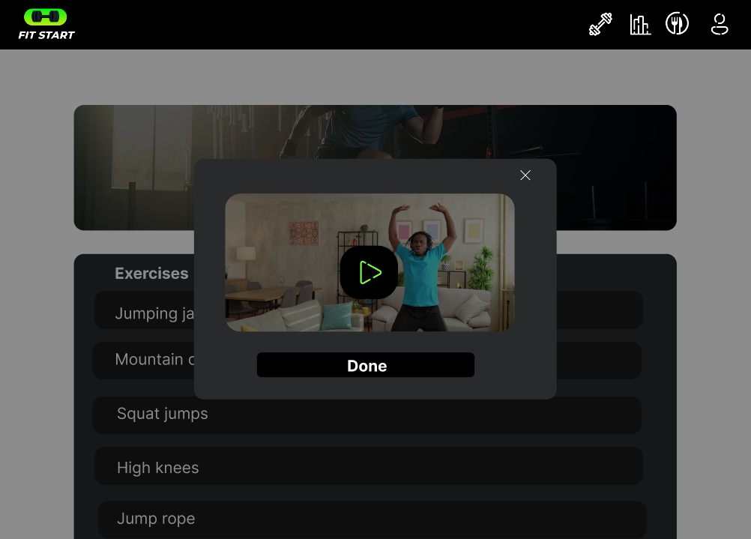The exercise popup features loading video to indicate when an action is being processed.

Figure 4 exercise popup

* + 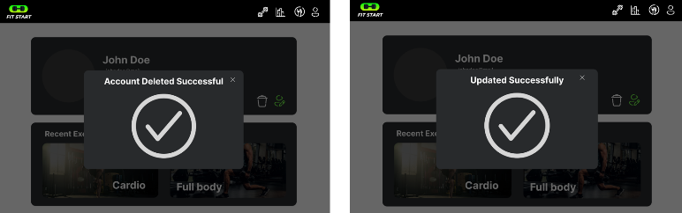Confirmation messages, such as "Profile updated successfully" or "Delete successful," appear to tell users when tasks are done .

Figure 5 success pop up

1. Match Between System and the Real World  
   Efforts were made to align the interface with real-world expectations and terminology to ensure familiarity (Freedman, 2019). Examples include:
   * The use of words like "Exercises" and "Leaderboard" corresponds with fitness app conventions, making navigating straightforward.
   * Icons such as a dumbbell for workouts or a trophy for the leaderboard are universally identifiable .



Figure 6 icons

1. User Control and Freedom  
   The prototype contains features for users to rewind or undo actions simply. For instance:
   * On the OTP confirmation and lost password pages, users can go back to the previous stage without losing progress.
   * 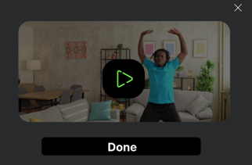During workouts on the exercise page, users can pause or terminate the session easily.

Figure 7 easy termination

* + The profile page enables the possibility to cancel edits before saving changes, ensuring users aren’t trapped into activities prematurely (Nielsen, 1994).

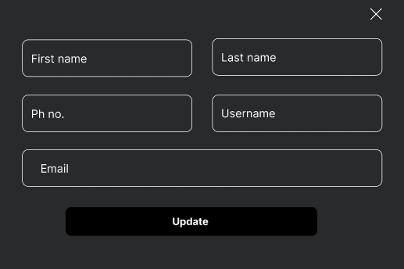

Figure 8 easy cancellation of profile edit

1. Consistency and Standards  
   Consistency is maintained across all pages to produce a unified experience (Cooper et al., 2007). Examples include:
   * Buttons, typefaces, and color schemes are similar throughout pages such as home, profile, and about us.
   * 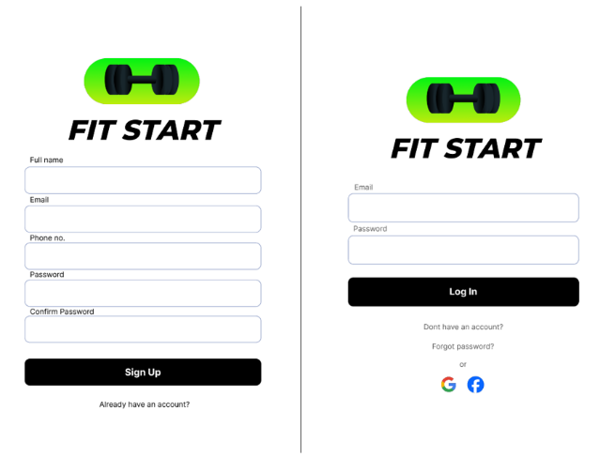Repeated activities, like submitting a form on the signup, login, or contact us pages, employ the same button style and layout for familiarity.

Figure 9 consistent design

* + Confirmation messages, such as “Success” popups, follow a uniform appearance to encourage predictability .

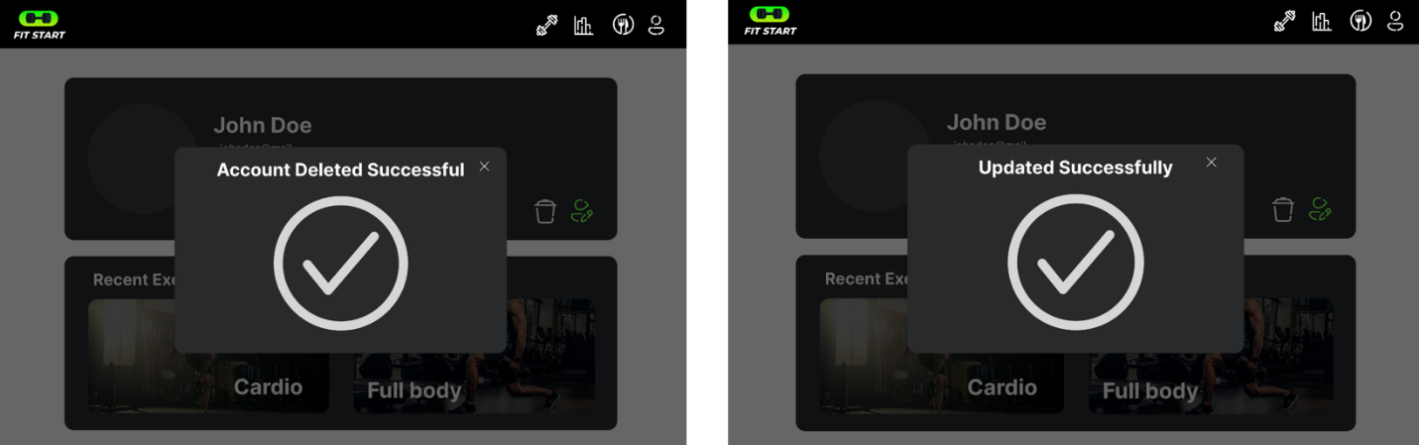

Figure 10 uniform appearance of pop-ups

1. Error Prevention  
   The design actively minimizes errors through preventive measures .For example:
   * On the signup page, real-time validation prohibits users from submitting forms with erroneous data, such as an incorrectly formatted email.
   * 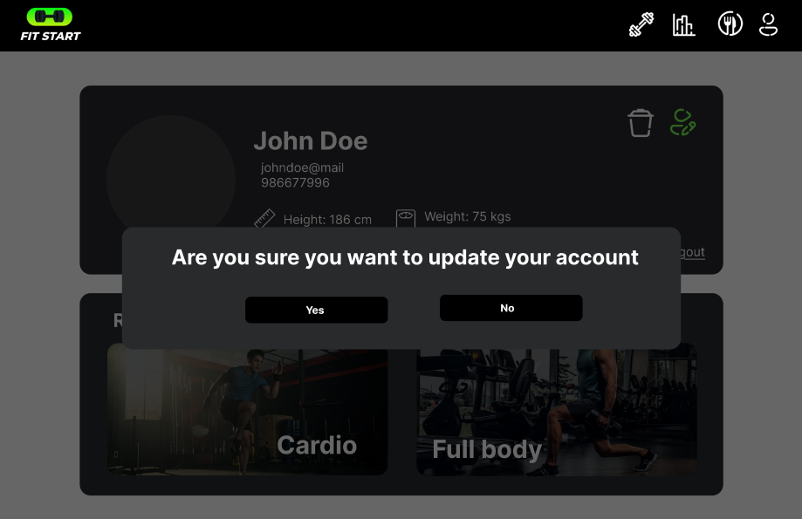Account update confirmation pops up before an account is updated.

Figure 11 update confirmation

1. Recognition Rather Than Recall  
   The program minimizes the cognitive effort by guaranteeing users can recognize options rather than recall them. Examples include:
   * 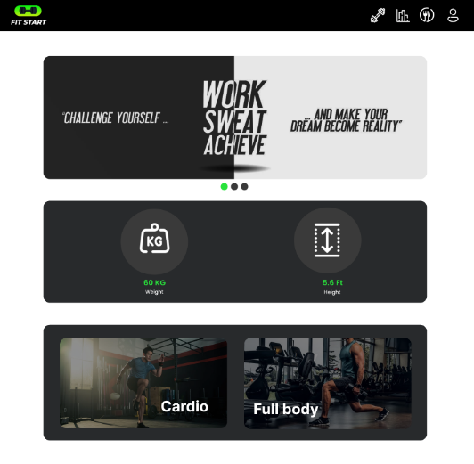The home page gives simple categories like "Exercises," so users don’t have to remember where specific features are placed.

Figure 12 homepage

* + Icons and labels on the league and leaderboard page let users recognize rankings without needing to recall what each metric signifies.

Figure 13 Leaderboards

* + 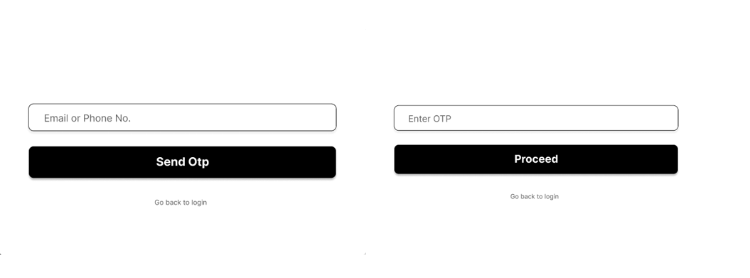On the forgot password page, visitors are directed step-by-step to guarantee they don’t have to recollect the process themselves .

Figure 14 different steps of password recovery

1. Flexibility and Efficiency of Use  
   The software caters to both novice and seasoned users by offering flexible settings. Examples include:
   * Advanced users can rapidly get to their favorite features utilizing the fixed navigation bar, which provides shortcuts to major sections like Home, Profile, and Leaderboard.

Figure 15 navigation bar and its shotcuts

* + The profile page features editable fields, allowing users to change their information effectively without re-entering all data.

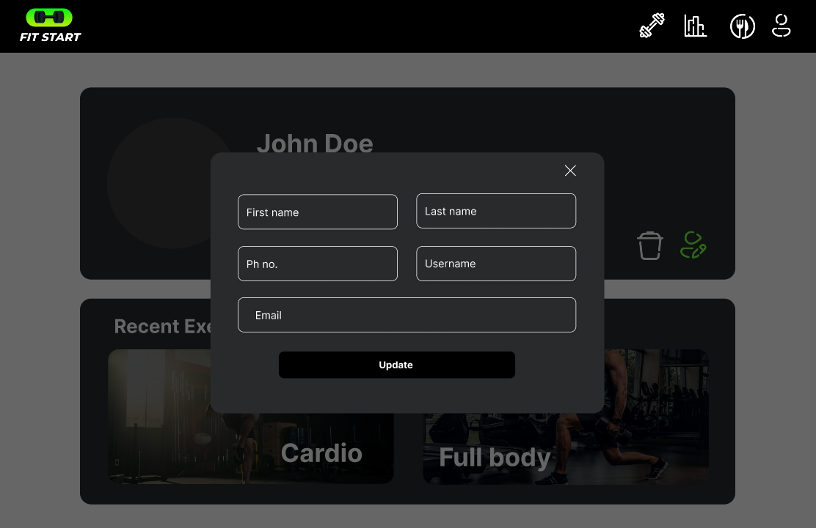

Figure 16 editable popup

1. Aesthetic and Minimalist Design  
   The prototype promotes simplicity and avoids clutter (World Health Organization, 2020). Examples include:
   * 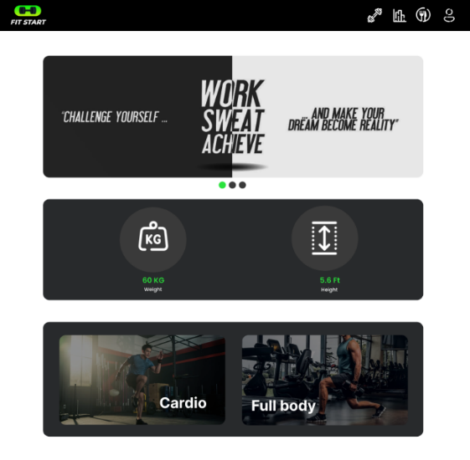The home page style is sleek and divides content into obvious divisions for Stats, Exercises, and banner.

Figure 17 sleek homepage design

* + The signup and login pages focus on relevant fields alone, reducing extraneous distractions.
  + Visual hierarchy is maintained with consistent space, fonts, and color contrast, ensuring that users can clearly identify critical elements like buttons and headlines (Freedman, 2019).

1. Help Users Recognize, Diagnose, and Recover from Errors  
   The software gives clear error notifications that help users fix difficulties fast. Examples include:
   * On the OTP confirmation page, customers are warned if the code is wrong and are provided an opportunity to resubmit the OTP.
   * Users are warned before an account is deleted.

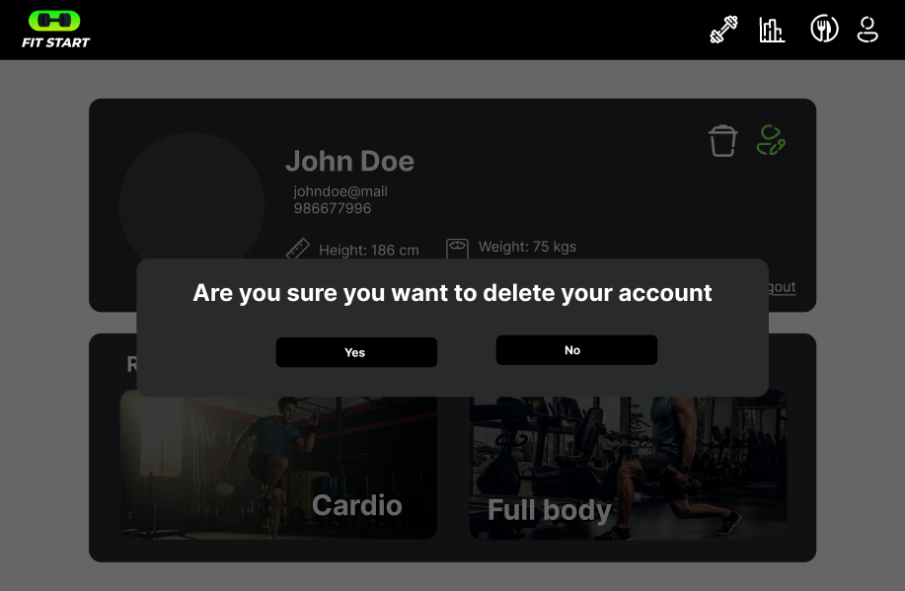

Figure 18 account delete confirmation

1. Help and Documentation  
   Although designed to be intuitive, the prototype contains help features when needed. Examples include:
   * 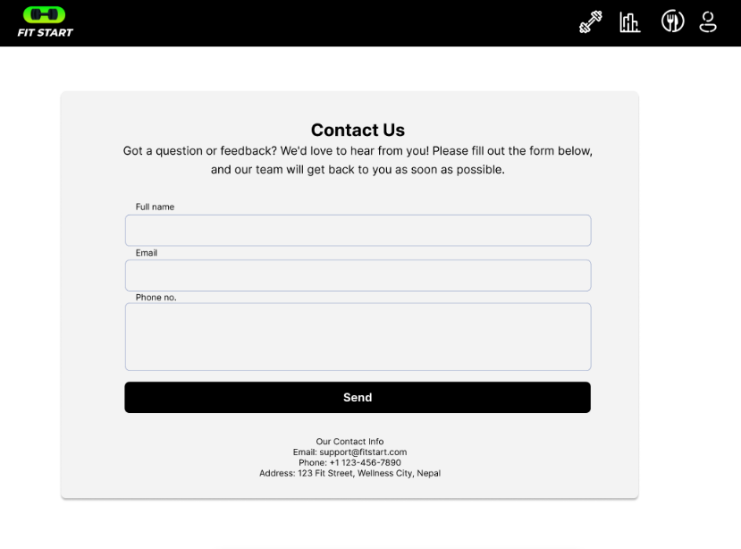The contact us page provides users with a direct way to reach help if they have concerns.

Figure 19 Contact us page

* + 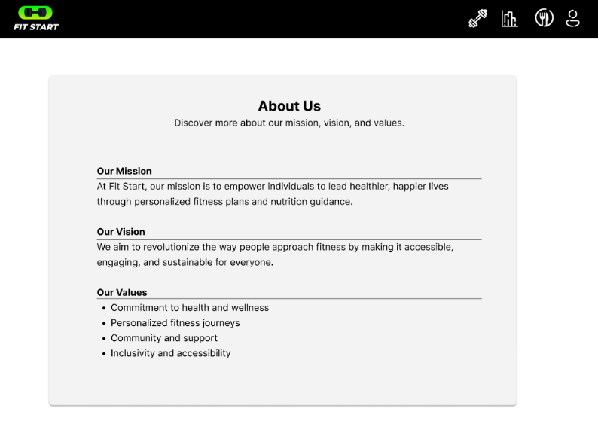The about us page defines the app’s purpose and features, helping users comprehend its functionality.

Figure 20 about us page

# Improvements

The high-fidelity prototype of the Fit Start app brought significant refinements based on feedback from previous testing phases, addressing usability issues and enhancing functionality. Key improvements included the implementation of a fixed navigation bar with clear labels for essential sections such as Home, Leaderboard, and Profile. This resolved navigation difficulties observed during the low-fidelity testing, making it easier for users to move between features without confusion (Brown, 2009).

The leaderboard, a highly appreciated feature, was enhanced to include filters for rankings by friends, location, and specific goals, making it more personalized and engaging. Visual feedback mechanisms, such as confirmation messages for actions like logging workouts and updating profiles, were introduced, addressing earlier concerns about the lack of clarity in task completion. These notifications improved the overall transparency of user actions.

The app’s visual design also underwent improvements, with consistent fonts, color schemes, and button styles applied across all pages to create a cohesive experience. Cluttered elements were removed, focusing on simplicity and ease of navigation. The quest tab, which users found redundant, was eliminated to streamline the interface and prioritize features like exercises and progress tracking.

Additionally, error prevention was enhanced by incorporating validation messages during tasks like signing up or entering incorrect OTPs, ensuring users received real-time guidance. Although many issues were resolved, testers highlighted the need for clearer onboarding to help new users navigate the app effectively, a feature planned for future implementation.

The improvements solidified the app’s user-friendly design, focusing on engaging and intuitive interactions. These refinements, combined with actionable feedback, provided a clear roadmap for the final product, ensuring it meets the needs of its diverse user base.

# Final Product

The Fit Start app completed in development as a comprehensive web application which employs the MERN stack framework with MongoDB, Express.js, React, and Node.js software. A performance-oriented architecture provided the foundation for this app since it blends scalable backend data management with powerful API capability and sophisticated frontend elements for interaction. Agile approaches utilized Scrum as their core framework and several iterative development sprints increased features like leaderboards and workout monitoring and user profile services. Continuous application improvements came from testing phase input to maintain user demands satisfaction. A superb synthesis of organized backend frameworks and user-friendly frontend design enables Fit Start to give a trustworthy fitness user experience for diverse types of consumers.

## Flat Design

Flat Design functioned as the key User Interface principle in the Fit Start app to achieve simplicity paired with clarity. The design style minimizes needless decorations such as gradients or 3D effects when it highlights simple characteristics and bright colors and basic pieces. The frontend design follows this idea to offer articles together in uncluttered sections which contain exercise features alongside leaderboard entries and profile components.

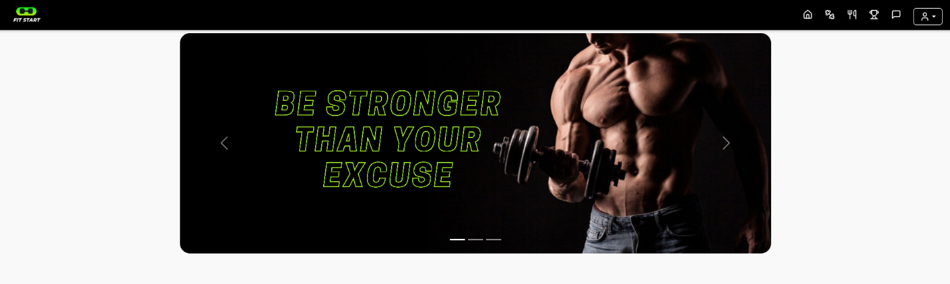

Figure 21 flat design

All interactive components benefit from distinct colors and well-spaced layouts to ensure users can recognize and manipulate them without complications. Flat Design reduces superfluous images to allow users to traverse effortlessly between app pages while staying focused on their health goals.

## Golden Path

Through the Fit Start app the Golden Path approach built an optimal user pathway that minimized step count and offered direct paths to critical tasks. The front page exposes users to important functionality including “Workouts,” “Leaderboards,” and “Meal” to promote rapid and uncomplicated access.

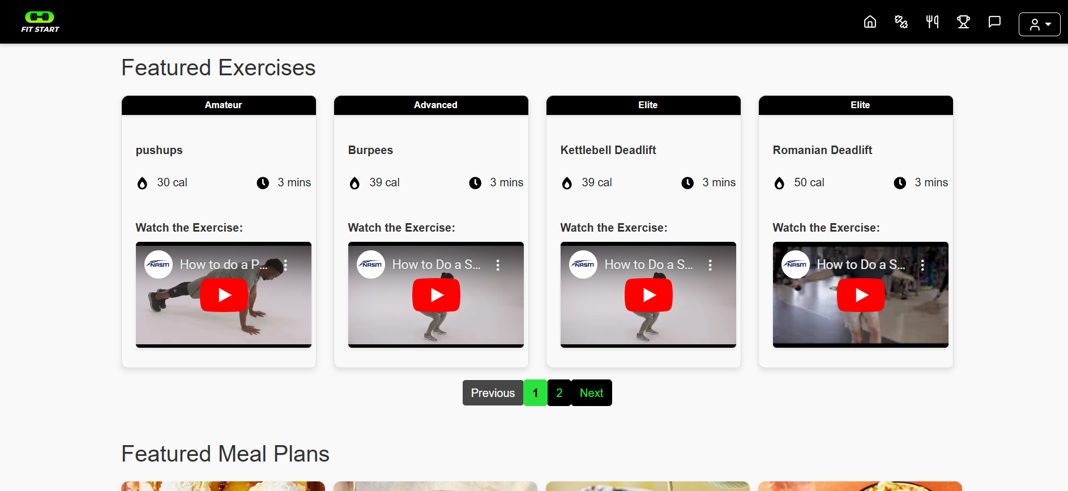

Figure 22 Different sections on home page

System navigation throughout exercise tracking leads users from workout selection to progress monitoring through an intuitive sequence and transparent directions. Users attain their objectives efficiently since the software removes potential distractions by retaining focus on vital operations.

## Shortest Path

The Shortest Path principle enables Fit Start app users to execute their chores quickly while focusing on time-saving functionality and easy usage. Users can examine leaderboard standings easily because this solution avoids needless menu stages in operations. Users benefit from direct workout selection from the exercise page which reduces the need for multi-step verifications. Users on the profile page access updating their information and monitoring progress without the need to move through other pages. The program streamlines interactions by eliminating extra processes, hence producing an easy-to-use interface where users can maintain their fitness goals plainly.

## 3-Tap Concept

The 3-Tap Concept was designed to offer users basic navigation to key elements and critical functions with minimal gestures spanning no more than three touches. Users can access all critical functionalities by no more than three consecutive taps within the app interface. Users also complete workout logging and profile modifications through three user-centered activities that minimize complexity.

## Crow’s Foot Notation

The database design of Fit Start app employs Crow’s Foot Notation to handle core entity relationships and achieve optimum data structure and administration. The users table links to three connected entities consisting of exercises, meals, and leaderboard scores.



Figure 23 crows foot o nav bar

Users can retain various workout entries and the database architecture offers one-to-many linkages allowing each user to construct multiple workout and meal diaries.

## Hex Principle

According to the Hex Principle, designers focus on balance and proportionality so every piece in Fit Start app provides a harmonious connection between all user experience components.

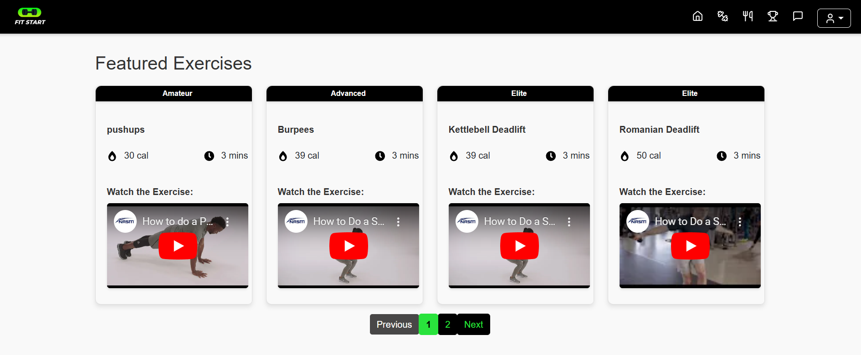

The approach led to page design uniformity which relied on consistent layout and precise spacing that matched identical alignments throughout home, leaderboards, and profiles sections.

## Metaphor

Users gain from greater interface understanding in the Fit Start app through Metaphor principles that relate interface elements with recognizable everyday notions. Through its leaderboard design, the system presents competition rankings in a fashion which resembles sporting events therefore helping users comprehend their standings in comparison to others. The activity monitoring page displays a stopwatch icon for workout duration coupled with an icon depicting exercise gear that helps visitors quickly grasp its meaning.

Figure 24 Leaderboards

Figure 25 Leaderboards

## 6:3:1 Design Rule

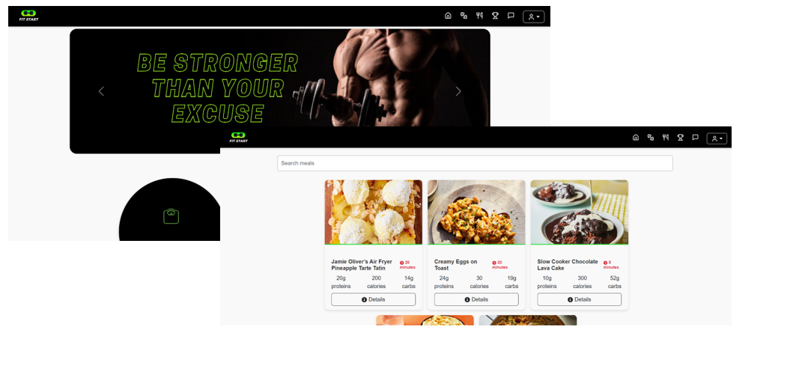The Fit Start app employed the 6:3:1 Design Rule to create a distinct visual hierarchy and direct users' focus through the smart application of colors. This strategy allocates 60% of the interface's emphasis to major activities with primary colors(white), 30% to secondary operations with complimentary tones(black), and 10% to supporting parts with accent hues(green).

Figure 26 6:3:1 rule implemented on colors

Figure 27 6:3:1 rule implemented on colors

The homepage prominently displays brilliant hues, including bold blues and greens, to emphasize essential areas such as “Workouts” and “Leaderboards.” Secondary elements, such as profile settings or meal tracking, are designed with muted, neutral tones that integrate seamlessly into the background while ensuring accessibility. Accent colors, including yellows and reds, are utilized judiciously for notifications, error messages, or call-to-action buttons. This organized color scheme guarantees clarity, boosts interest, and assists users in effectively identifying key features.

## Emotional Design Model

The Emotional Design Model was implemented into the Fit Start app to produce a positive, engaging experience by addressing three levels of design—visceral, behavioral, and reflective. Visually, the app employs modern aesthetics with easily recognizable symbols. Behaviorally, the app emphasizes usability through straightforward navigation and efficient operations. Reflectively, the app’s monitoring functionality and precise statistics enable users to analyze their fitness progress, fostering continuous engagement.

# Conclusion

The implementation of Fit Start displays successful user-centered design through its effective marriage of robust functionality with easily usable and visually stunning interface design. The MERN stack architecture enables development of this app alongside guided iterative feedback to provide fundamental features enabling workout monitoring and leaderboards, as well as individualized user profiles that promote fitness journey participation. Interface design features familiar with Flat Design, Golden Path principles, and Emotional Design methodology create a solution that integrates simplicity with efficiency and user engagement. Active testing led to feature optimizations as users provided feedback for content removal, focusing attention on important duties. The system design and flexible infrastructure of the application enable improvement for future enhancement demands. Users achieve their exercise goals effectively because of Fit Start’s seamless design, which integrates user needs with platform functions while generating a compelling user journey.

# References

* Brown, T. (2009). *Change by Design: How Design Thinking Transforms Organizations and Inspires Innovation*. Harper Business.
* Cooper, A., Reimann, R., & Cronin, D. (2007). *About Face 3: The Essentials of Interaction Design*. Wiley.
* Deterding, S., Dixon, D., Khaled, R., & Nacke, L. (2011). From Game Design Elements to Gamefulness: Defining “Gamification.” In *Proceedings of the 15th International Academic MindTrek Conference* (pp. 9–15).
* Fogg, B. J. (2009). A Behavior Model for Persuasive Design. In *Proceedings of the 4th International Conference on Persuasive Technology*.
* Freedman, T. (2019). *Design Patterns for Modern Web Development with React and Node.js*. Apress.
* Harrington, H. J. (2011). *Business Process Improvement: The Breakthrough Strategy for Total Quality, Productivity, and Competitiveness*. McGraw-Hill.
* Kettunen, O. (2021). Gamification in Health and Fitness Apps: A Systematic Review. *Journal of Health Informatics*, 12(2), 45–53.
* Nike Inc. (n.d.). *Nike Training Club*. https://www.nike.com/ntc-app
* Nielsen, J. (1994). *Heuristic Evaluation*. In J. Nielsen & R. L. Mack (Eds.), *Usability Inspection Methods* (pp. 25–62). Wiley.
* Norman, D. (2004). *Emotional Design: Why We Love (or Hate) Everyday Things*. Basic Books.
* Norman, D. (2013). *The Design of Everyday Things* (Revised and Expanded ed.). MIT Press.
* Schwaber, K., & Sutherland, J. (2020). *The Scrum Guide*. <https://scrumguides.org>
* Smith, J. (2022). Digital Fitness and Community Engagement: A Contemporary Analysis. *International Journal of Sports Technology*, 11(3), 101–117.
* Strava. (n.d.). *Strava Official Website*. <https://www.strava.com/>
* World Health Organization. (2020). Global Recommendations on Physical Activity for Health. <https://www.who.int/>

# Appendix

## Links

**Usability Test Form for Wizard of Oz:** <https://docs.google.com/forms/d/e/1FAIpQLSdah3qnmE48jCYyh5UrWnAP8d-IEoIrjEq_Tug1pf2jDy0KTQ/viewform?usp=header>

**Video of Wizard of Oz:**

<https://youtu.be/39kbwtT28zg>

<https://drive.google.com/drive/folders/1ex0V81XhD_NTmnlfCBZyiZViXQK15Ods?usp=drive_link> (if youtube doesn’t work because of verification issues)

**Usability Test Form for Guerrilla Testing:**

<https://docs.google.com/forms/d/e/1FAIpQLSeaW5qDvfjtnoRD15L-A87YcheoKbyAgjLZB-hdn0KRAPB2Kg/viewform?usp=sf_link>

**Video of Guerrilla Testing:**

<https://youtu.be/hIaTxGMuo9o>

**Link for Figma design:**

<https://www.figma.com/design/2uiUZOFrn3Zxzu4CHuh0pe/ux-prototype?node-id=0-1&t=1tP9w49DkMS3Z1Gi-1>

**GitHub frontend and backend:**

<https://github.com/rajil-s/web-fit-start>

**Final development video link:**

<https://youtu.be/l3O3l7p--xo>

## Persona

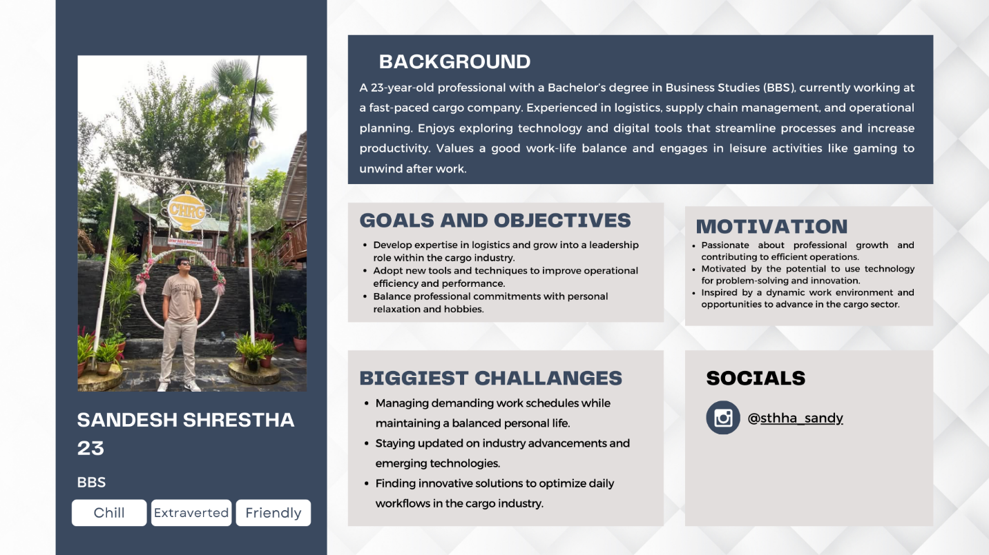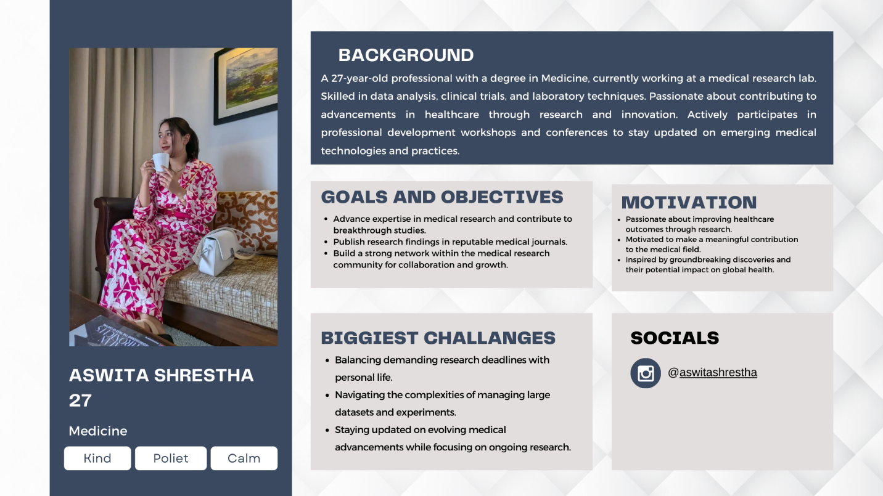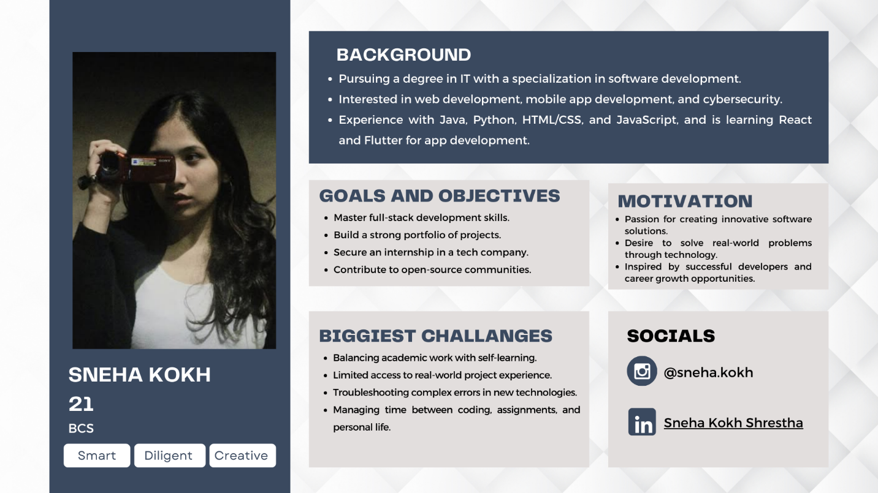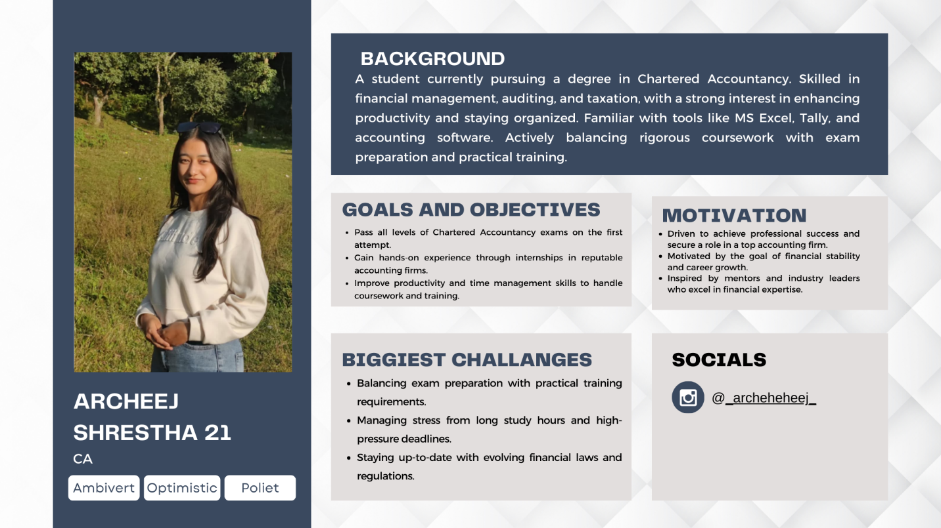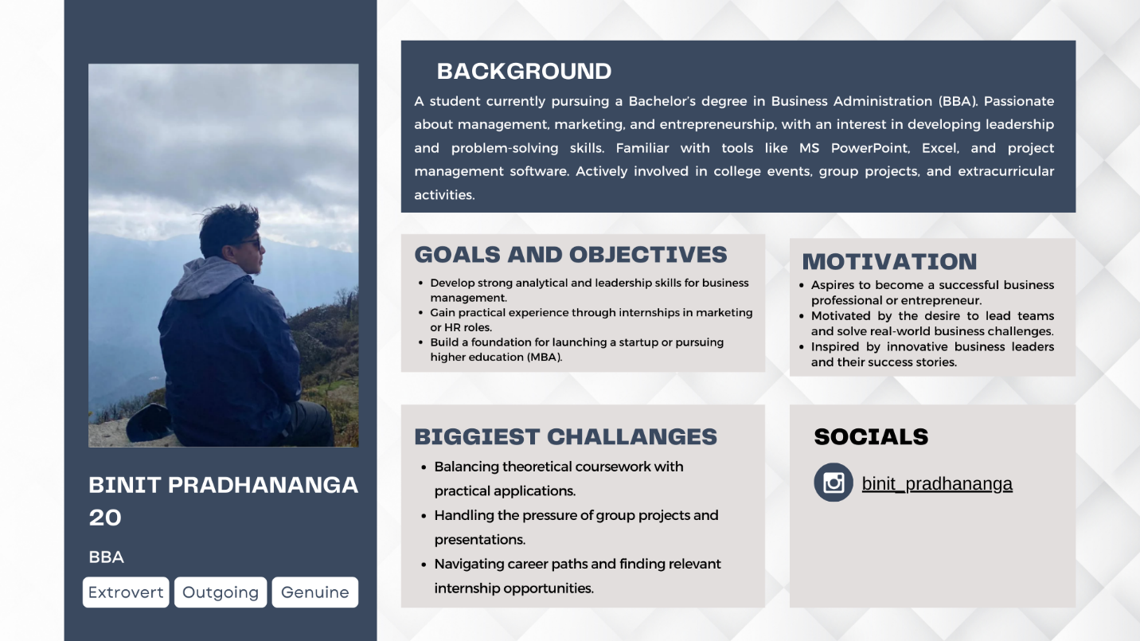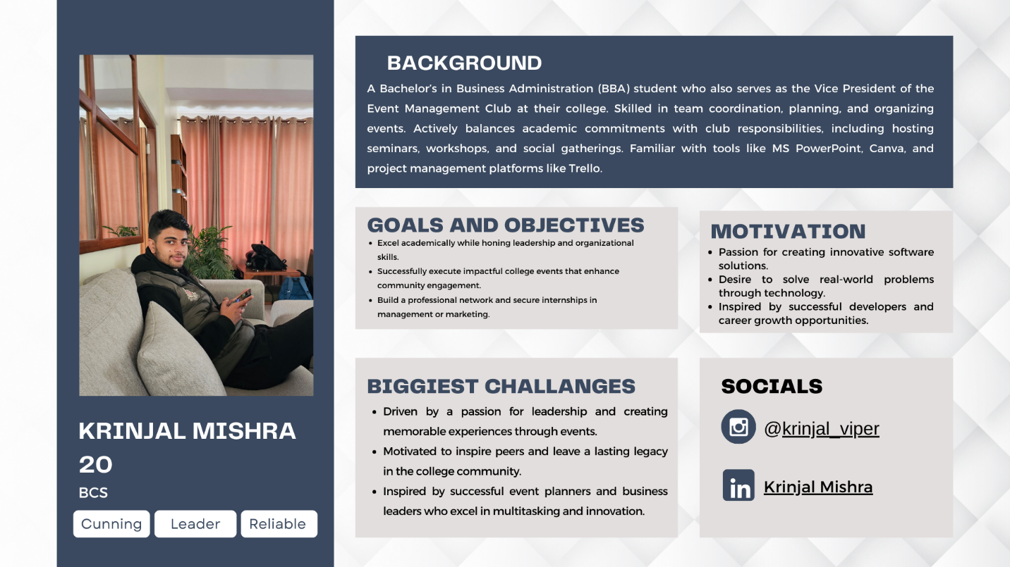

## Consent Form

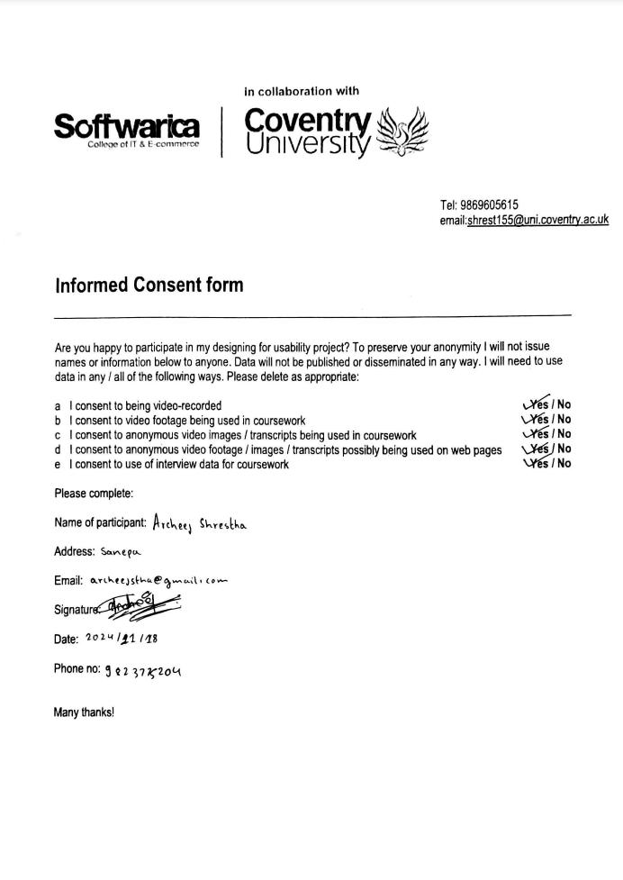

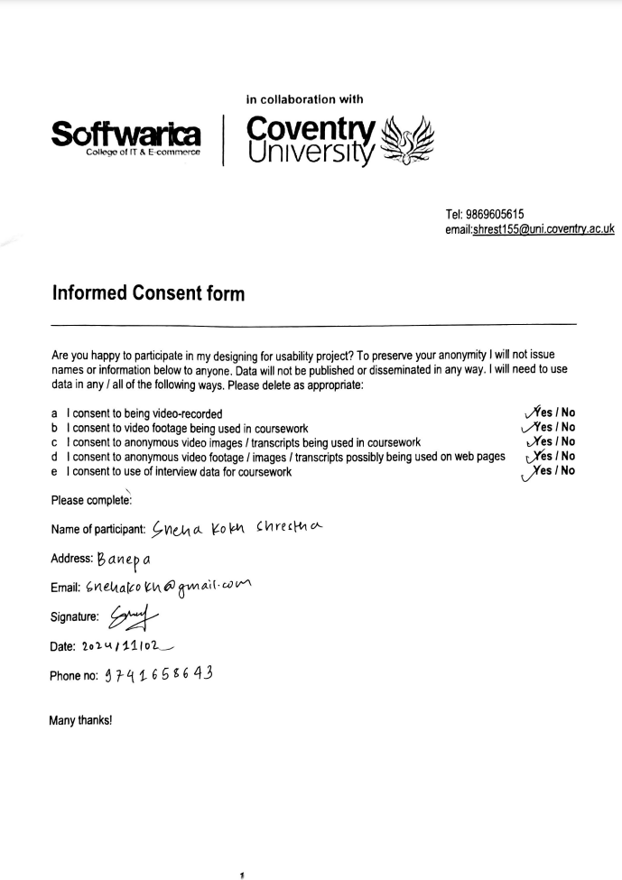

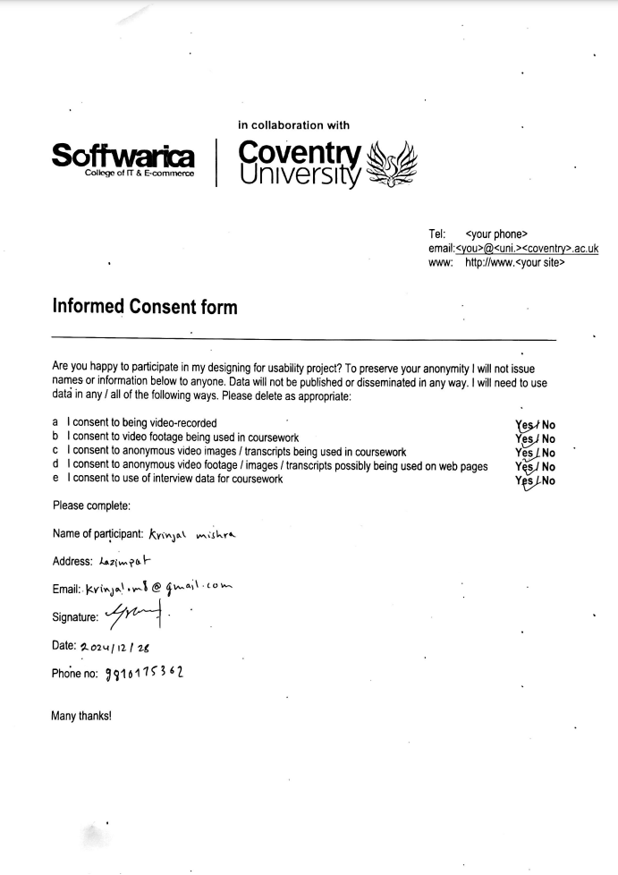

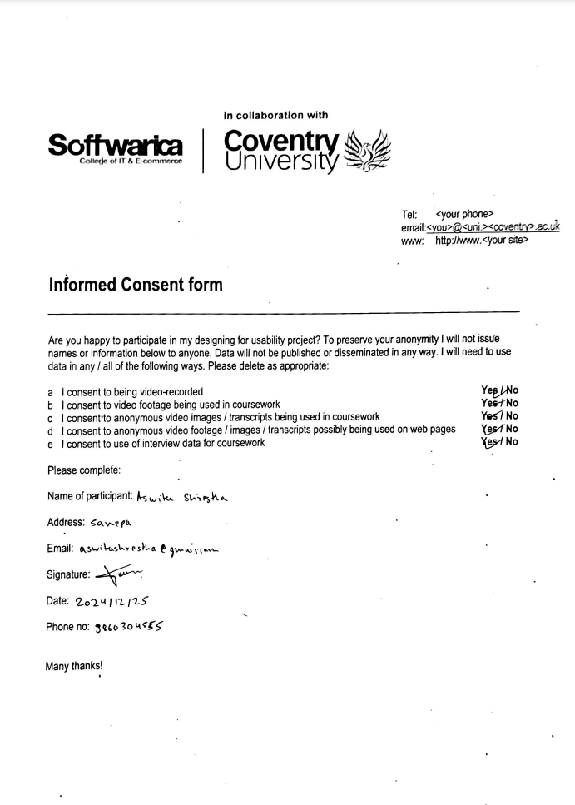

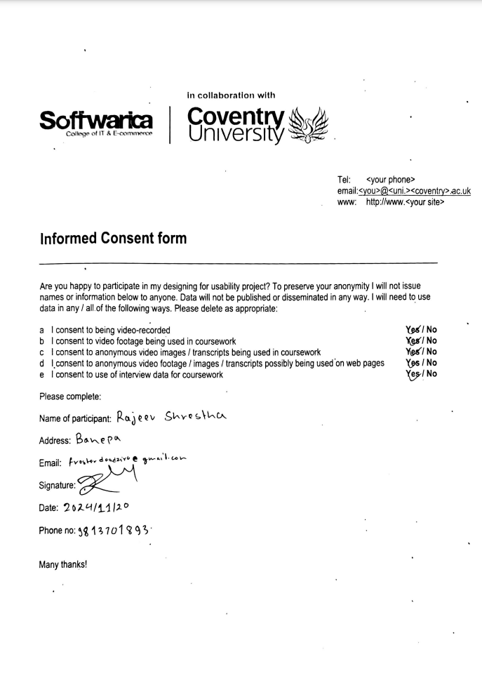

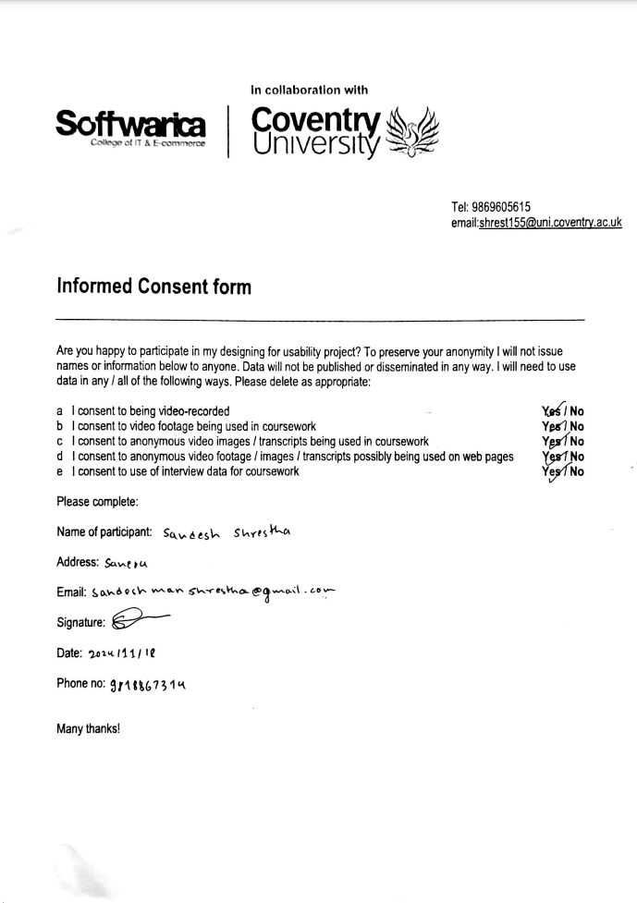

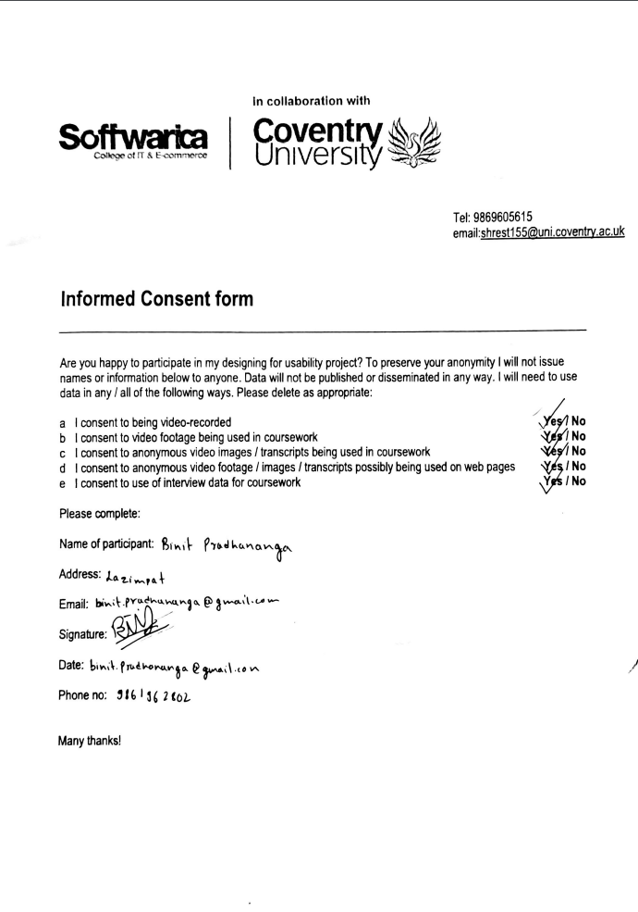

## Low Fidelity Prototype Pictures

